**©** [**www.tekartlearning.com**](https://www.tekartlearning.com/) **Page 1**

*For More Visit* [*www.tekartlearning.com*](http://www.tekartlearning.com/)



*For More Visit* [*www.tekartlearning.com*](http://www.tekartlearning.com/)

**Year:**

**Name: School:**

*For More Visit* [*www.tekartlearning.com*](http://www.tekartlearning.com/)

*Table of Contents*

PAPER 1 3

PAPER 2 13

PAPER 3 24

PAPER 4 33

PAPER 5 43

PAPER 6 53

PAPER 7 64

PAPER 8 75

PAPER 9 86

PAPER 10 96

PAPER 13 126

PAPER 14 135

For more Booklets of this kind, Visit [www.tekartlearning .com](http://www.tekartlearning.com/) or call +256754895241

|  |
| --- |
| **PAPER 1** |
| **SECTION A. (40 Marks)**   1. **Name any one product got from a domestic bird.** 2. **Give the use of a toilet at school.** 3. **Why do farmers provide houses to their farm animals?** 4. **Identify any one insect that lives in soil.** 5. **Identify the method of preserving food shown below.**   Description: http://upload.wikimedia.org/wikipedia/commons/thumb/9/9c/North_carolina_algonkin-essen02.jpg/300px-North_carolina_algonkin-essen02.jpg   1. **Why is a lion dangerous to people?** 2. **Which clouds are a sure sign of rainfall?** 3. **Draw a garden tool used for cutting big trees.** |

1. **Name any one place where children are taken for immunization.**
2. **Which gas is given out by plants during photosynthesis?**
3. **Write any one type of family in your sub-county / Division.**
4. **Why are people advised to drink boiled water?**
5. **Why should every family start a tree planting project in our community?**
6. **Name any one play material that children can make at home.**
7. **What does the diagram below show about air?**

**glass**

**Air bubbles**

**water**



1. **How is strong wind dangerous to a person using a boat?**
2. **Why do farmers mulch their gardens?**
3. **Name any one element of weather.**
4. **How is a mortar and a pestle useful in a kitchen?**
5. **Identify any one method of planting maize.**
6. **Why do farmers dry cereal crops before storing them?**
7. **Why is it dangerous to disturb bees in their hives?**
8. **Give any one way of avoiding mosquito bites in your bedroom.**
9. **Write any one danger of the sun.**
10. **Name the food value got from eating beans.**
11. **Which body organ is cared for by wearing sunglasses?**
12. **Identify any one item used to keep your classroom clean.**
13. **How do you care for pit latrines?**
14. **Apart from decomposition, give any other way in which soil is formed.**
15. **State any one role of children at home.**
16. **Give the use of a rake to farmers.**
17. **How do you care for your school shoes?**
18. **Name any one plant that grows well in a desert.**

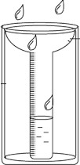The diagram below shows a rain gauge.

1. **Of what use is the above instrument to people?**
2. **Give any one effect of poor feeding in children.**
3. **How is the larva stage of a butterfly dangerous to crop farmers?**
4. **State any one use of moving air to people.**
5. **Give any one reason for carrying casualties to hospitals.**
6. **Draw any one item made from wood/ timber.**
7. **Give any one importance of things we make like bags.**

SECTION B : (60 MARKS)

1. **(a) Name any two common accidents at home.**
2. **State any one cause of road traffic accidents.**
3. **Give any one way of reducing accidents on our roads.**
4. **(a) Name any two things you can do to promote personal hygiene.**
5. **What problem can result from failing to keep the body clean?**
6. **Draw any one item used to care for your body parts.**
7. **(a) Name any two examples of crop pests.**
8. **Write any one way of controlling pests in a garden.**

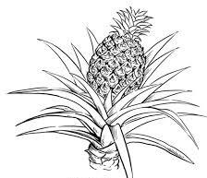

1. **How is a granary useful to a crop farmer?**
2. **The diagram below shows a flowering plant.**

P

1. **Identify the flowering plant shown above.**
2. **Why is the above plant grouped under flowering plants?**
3. **Give the use of part P to the plant.**
4. **What food value is got from eating the above plant?**
5. **(a) Give any one natural change in the environment.**
6. **Write any two effects of natural changes in the environment. (i)**

(ii)

1. **How can natural changes in the environment be controlled?**
2. **Match the following correctly.**

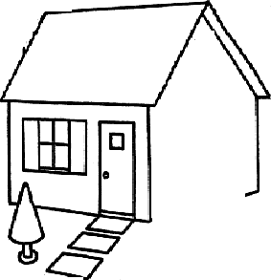

Animal movement

Cow swimming

Fish leaping

Toad flying

Bee walking

1. **Cow**
2. **Fish**
3. **Toad**
4. **Bee The diagram below shows a house. Use it to answer question 47.**

S R

T

1. **(a) Name part marked S and T above.**

S T

1. **Identify any one item used to make part R.**
2. **Give any one use of a house to people.**
3. **(a) What is germination?**
4. **Write any two conditions needed by a seed to germinate. (i)**

(ii)

1. **Give any one way of caring for seedlings.**
2. **The diagram below shows a common item. Use it to answer the questions that follow.**
3. 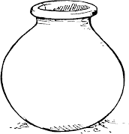**From which material is the above item made?**
4. **How is the above item useful to people?**
5. **Why should the above item be handled with care?**
6. **How can you keep the above item clean?**
7. **(a) Identify any two places where rubbish can be disposed properly.**
8. **Name the insect that is commonly found in dirty places.**
9. **Write any one danger of staying in a dirty place.**
10. **(a) Who heads most normal families in our community?**
11. **Name any two groups of people in a family. (i)**

(ii)

1. **Who breastfeeds a baby in a family?**
2. **(a) Give one example of an energy giving food.**
3. **Name any one use of food in the body.**
4. **State any two dangers of poor feeding. (i)**

(ii)

1. **(a) Identify any one main part of an insect.**
2. **Write any one characteristic of insects.**
3. **Give one example of each of the following;**
4. **useful insects**
5. **harmful insects**
6. **(a) Name any two sources of water in our sub-county / Division.**
7. **Give the use of water to wild animals.**
8. **Write any one human activity that can make water sources dirty.**
9. **The pictures below show wild animals.**

|  |  |
| --- | --- |
| **A** | **B** |

1. **Identify the animals shown above.**
2. **A**
3. **B**
4. **Name the habitant for animal A.**
5. **How is animal B dangerous to people?**

|  |
| --- |
| **PAPER 2** |
| **SECTION A. (40 Marks)**   1. **How many legs has a spider?** 2. **Give one danger of long fingernails.** 3. **How is a dustbin useful in a classroom?** 4. **Write any one member of a nuclear family.**   **Below is an object found in our environment.**  http://www.clipartguide.com/_named_clipart_images/0511-1005-1115-5616_Broken_Wine_Bottle_clipart_image.jpg   1. **How is the object above dangerous to children?** 2. **Why do farmers mulch their gardens?** 3. **How can you protect yourself against tooth decay?** 4. **Which element of weather dries our clothes?** 5. **Name any one living component of the environment.** 6. **On which part of an insect are the wings attached?** |
|  |

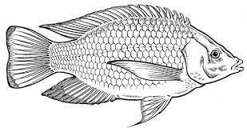

1. **How is a latrine useful to people?**

The diagram below is of a fish. Use it to answer question 12.

Y

1. **Give the function of part marked Y.**
2. **Why do dogs bark at strangers?**
3. **How can you care for crops in the dry season?**
4. **Write one danger of playing from the kitchen.**
5. **Give any one use of shadows to people.**
6. **Identify one function of leaves to a plant.**
7. **Name the immunisable disease that makes children lame.**
8. **In which way can wild animals be dangerous to people?**
9. **Why is it a good practice to put on gumboots on a rainy day?**
10. **How does a bat move from one place to another?**
11. **Draw a garden tool used for collecting rubbish.**
12. **Give any one danger of strong wind to people.**
13. **Write down the first aid for burns.**
14. **Name one human activity that can lead to soil erosion.**
15. **Why are casualties given first aid?**
16. **How are houseflies dangerous to people?**
17. **Identify any one food stuff that people eat without cooking it.**
18. **Name the habitat of a frog.**
19. **How can people protect their eyes on a sunny day?**
20. **State one way of keeping water sources clean.**
21. 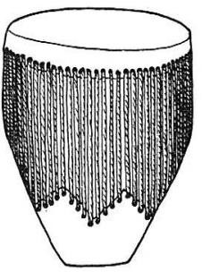**The diagram below shows a drum.**

Name one animal whose skin is used to make the drum.

1. **Give one way you can reduce pests in the garden.**
2. **Give one use of a panga at home.**
3. **Draw and name any one wild animal that can kill people.**
4. **How can family members protect themselves from mosquito bites at home?**
5. **How can you protect your food from being contaminated?**
6. **Give one reason why people keep birds at home.**
7. **How can you help a blind man or woman in your village?**
8. **Give any one use of soil to people.**

SECTION B

1. **The diagram below shows life cycle of an insect. Use it to answer**

the

questions below.

Eggs

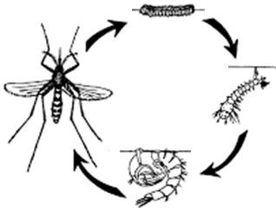

N

Q

P

* 1. **Name the stages marked Q and N**

N Q

* 1. **Give two insects whose life cycle is similar to the one shown above.**

3. **Write any two causes of road accidents.**

b) How can road accidents be controlled?

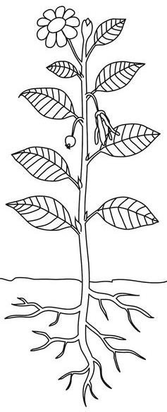


2. **a) What is weather?**
3. **Identify the type of weather that leads to drought.**
4. **Give any two elements of weather.**

7. **The diagram below is of a flowering plant. Use it to answer the questions below.**

K

L

S

T

* 1. **Name part marked S.**

1. 1. **Give the function of parts marked T and L to the plant.**
2. **L** 
   1. **Why do bees visit part K?**
3. **a) Why do we eat food?**



1. **Give any one use of food in the body.**
2. **How can you preserve the following food stuffs?**
3. **fish**
4. **beans**
5. **Match these animals**

Animal movement

Fish - walking

Snake - slithering

Grasshopper - swimming

Cow - hopping

* 1. **Fish**
  2. **Snake**
  3. **Grasshopper**
  4. **Cow**

1. **a) Name the property of air shown below.**

glass water

card board

b) How is the above property useful to people?

|  |  |  |
| --- | --- | --- |
| **c) Give any two other properties of air.**     3. **a) Write any two examples of seeds eaten by people.**   **b) Identify any two things needed by a seed to germinate.**       **49. a) Apart from clay , name any other type of soil**  **b) Why is clay soil the best for making pots?**  **d) Name one thing which is added to sand soil when building a house.**  **d) Give one way in which we can make the soil more fertile.**  **50. a) Draw and name any one item used to clean our school compound.** | | |
|  |  |  |
|  |

1. **Where can pupils at school put the rubbish?**

4. **Why should you wash your hands after cleaning the compound?**
5. **a) Write one example of natural changes in the environment.**
6. **Identify any two natural causes of changes in the environment.**

9. **Name one human activity that causes changes in the environment.**
10. **a) Give any two characteristics of living things.**
11. **Apart from animals, give any other group of living things.**

_

1. **Where do wild animals such as lions live?**
2. **The diagram below shows part of the human body.**

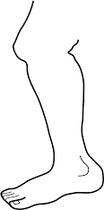

K

1. **Name the part of the body shown above.**
2. **Give the use of the body part shown above.**
3. **Identify part marked K on the diagram above.**
4. **How do you care for the body part above?**
5. **Write any two sources of water in our division.**

b) Give any two uses of water to people.

3. **The diagram below is of a living thing. Use it to answer the questions**

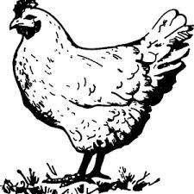

below. B

D

A C

1. **Name part labeled D.**
2. **What is the use of part A to the bird?**
3. **Give any two uses of that bird to people.**

|  |
| --- |
| **PAPER 3** |
| **SECTION A. (40 Marks)**   1. **Name one domestic animal that provides us with milk.** 2. **How useful is a broom in your classroom?** 3. **Why is a hen grouped under living things?** 4. **How are rats dangerous to a crop farmer?** 5. **What food value do we get when we eat the animal below?**      1. **Give one role of a mother at home.** 2. **Give one domestic animal used for transport.** 3. **Why is it dangerous to share clothes with other people?** 4. **Give one use of leaves to people.** 5. **Give any one effect of accidents to people.** |

1. **Why should a casualty be given first aid?**

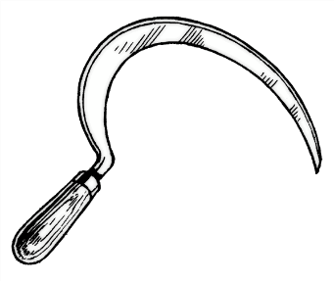

1. **How is the garden tool below useful to a farmer?**
2. **Name any one disease that has no cure.**
3. **Why do we need to bathe everyday?**
4. **Why is a spider not referred to as an insect?**
5. **How is too much sunshine dangerous to crop farmers?**
6. **How is a shadow useful to people?**
7. **Why should we have a dustbin in our classroom?**
8. **Give the use of a toilet at home.**
9. **Identify any one use of feathers to birds.**
10. **Name the animal waste used for smearing the floor of a house.**
11. **Identify the health practice done before eating food.**

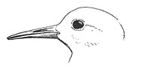

1. **Name part of the bird marked B.**

B

1. **How is a housefly dangerous to people?**
2. **Name any one place where people can get food.**
3. **Give one use of trees found in the school compound.**
4. **Name one tool that we can use to keep our bodies clean.**
5. **Why are farmers advised to keep metallic garden tools in a cool dry place?**
6. **Give one element of weather.**
7. **Why should pedestrians cross a busy road at a zebra crossing?**
8. **How is electricity useful at home?**
9. **Why should we boil water for drinking?**



1. **Name one thing we can make from banana fibres.**
2. **The diagram below shows a garden tool.**

Give the use of the garden tool above.

1. **Name any one fruit we eat at school.**
2. **Identify any one danger of poor feeding to a P.3 child.**
3. **What food value do we get from eating cassava?**
4. **Why is it advisable to sleep under a treated mosquito net?**
5. **Give one component of the environment.**
6. **How can dogs be useful at home?**

SECTION B:

1. **(a) Write down any two components of soil.**

(b) Give two ways of controlling soil erosion.

3. **(a) Name any two common diseases in our homes.**
4. **What vector spreads malaria?**
5. **Give one way of controlling malaria at home.**
6. **Match the animals in A to their homes in B correctly. A B**

Dog den

Fish tree

Monkey kennel

Lion water

* 1. **Dog**
  2. **Fish**
  3. **Monkey**
  4. **Lion**

1. **(a) Name two areas at home that must be kept clean.**

(b) How can we keep our homes clean?

3. **(a) Draw and name any two things we use to keep our bodies clean.**

|  |  |
| --- | --- |
|  |  |
|  |  |

(b) Write two dangers of not keeping our bodies clean.

3. **(a) What name is given to a sudden happening that causes harm to the body?**
4. **What is first aid?**
5. **Give two reasons why we give first aid.**

8. **(a) What are domestic animals?**
9. **Identify any two examples of domestic animals.**


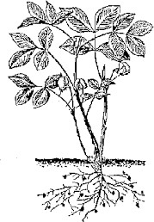

1. **Give one way of caring for domestic animals.**
2. **The diagram below shows a plant.**

A

B

C

1. **Which part is used for sucking water?**
2. **Give two uses of plants to people.**

5. **Name one example of a harmful plant.**
6. **(a) What is a balanced diet?**
7. **Write two food values that make up a balanced diet.**

10. **How is food important in the body?**
11. **(a) How is AIDS spread?**
12. **How is AIDS dangerous to people?**
13. **Give two ways of caring for AIDS patients. (i)**

(ii)

1. **Give two natural causes of changes in the environment.**
2. **Name one man made change in the environment.**
3. **How can you care for trees at home?**

The diagrams below show properties of air. Use them to answer questions that follow.

B

A

1. **(a) Identify the properties of air marked A and B.**
   1. **A**
   2. **B**
2. **How is Carbondioxide useful to people?**
3. **Which part of air is needed for burning?**
4. **(a) Name one source of water.**

(b) Give three uses of water at home. (i)

(ii)

2. **(a) What is mulching?**
3. **Give two importance of mulching a garden. (i)**

(ii)

1. **State one danger of the sun.**
2. **Use the words below to fill in the gaps below correctly.**

mosquitoes , spraying insecticides , hairy body , vectors

are living organisms that spread disease germs. Examples of common vectors are houseflies, and cockroaches. House flies are able to spread germs using their

. We control vectors by draining stagnant water and .

|  |
| --- |
| **PAPER 4** |
| **SECTION A. (40 Marks)**   1. Name the sense organ for hearing. 2. Why are bees grouped under insects? 3. Which activity in personal hygiene is carried out using soap? 4. Who is a grandmother in an extended family? 5. Give **one** example of a body-building food. 6. Why do people cross a busy road at a zebra crossing? 7. How does the animal below move from one place to another?   Description: C:\Users\user\Desktop\images\snake.jpg   1. Write down any **one** behaviour that is accepted in our community. 2. Why is it dangerous to have poor feeding in children? 3. What is a balanced diet? 4. Why is a stone grouped under non-living things? |

1. How do children prevent tooth decay?
2. How are floods dangerous in the environment?
3. In which way is a dog useful at home?
4. Name the childhood immunisable disease that makes children lame.
5. What danger would a housefly get if its spiracles were blocked?
6. Identify the main natural source of water.
7. State **one** reason why you need a dustbin in your classroom?
8. What type of weather is the best for winnowing seeds?
9. Why do people keep hens at home?
10. How is the tool below useful in a home?

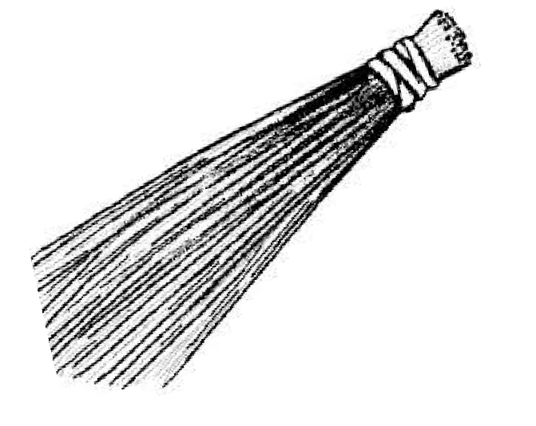

1. **Complete the diagram by drawing a shadow.**

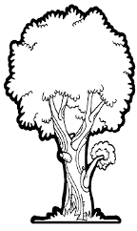

1. How is the changing of colours useful to a chameleon?
2. Give **one** reason why loam soil is suitable for crop growing.
3. How are fire extinguishers useful in a school?
4. Why is it dangerous to look at the sun directly without sun glasses?
5. How are nimbus clouds important to a crop farmer?
6. How are female anopheles mosquitoes dangerous to people?
7. Why is it important to bathe daily?
8. How is strong wind dangerous in the environment?
9. Give any **one** reason why we plant trees in the school compound.
10. 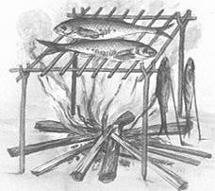Identify the method of preserving food shown below.
11. How can we care for plants during drought?
12. Identify any **one** tool that people use to keep an area clean.
13. Give any **one** way of caring for garden tools.
14. What is the standard unit for measuring length?
15. Give any **one** importance of the sun to people.
16. Name any **one** dangerous insect found in pit latrines.
17. Why is it dangerous for children to play along the road?
18. Draw any **one** item found in a first aid box.

|  |  |  |  |
| --- | --- | --- | --- |
| **SECTION B**  41. (a) What is air?  (b) Write down any **two** components of air.       (c) Which property of air enables us to suck soda from a bottle?  42. (a) Why do people use umbrellas on a rainy day?  (b) Give any **two** dangers of too much rain to people.       (c) Draw any **one** item used for harvesting rain water.  43. (a) Draw the following items used to keep the body clean. | | | |
|  |  |  |  |
| **toothbrush** | **comb** |

* 1. Give any **one** danger of failing to clean your body.
  2. How do you care for your hair?

1. (a) Write down any **two** animals at home whose meat we eat.

(b) State any **two** ways we can care for the animals above.

3. **The picture below shows a child suffering from an immunisable disease.**

skin rash

red eyes

running nose

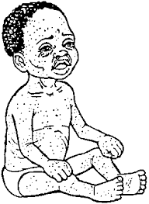

1. Name the disease the child is suffering form.
2. How is the above disease prevented in children?
3. Apart from the above disease, give **one** other immunisable disease you know.
4. Give any **one** way of caring for sick people.
5. (a) What is germination?
6. Apart from water, name any other **two** conditions necessary for germination.

9. Give another use of seeds to people at home.
10. (a) Name any **one** living component of soil.
11. Give any **two** ways of keeping soil fertile.

14. How is soil formed?
15. **Match the words in A with those in B correctly. A B**

Cow den

Rabbit kennel

Lion hutch

Dog kraal

A B

Cow Rabbit

Lion Dog

|  |  |  |
| --- | --- | --- |
| 49. | (a) | Apart from malaria , mention any other **two** common diseases. |
|  | (i) |  |
|  | (ii) |  |
|  | (b) | How can we prevent malaria at home? |
| 50. | (a) | What is weather? |
|  |  |  |
|  | (b) | Write any **two** elements of weather. |
|  | (i) |  |
|  | (ii) |  |
|  | (c) | Which condition of weather makes people wear gumboots? |
| 51. | (a) | Give **two** reasons why we should give first aid. |
|  | (i) |  |
|  | (ii) |  |
|  | (b) | Write any **two** ways we can prevent accidents at home. |
|  | (i) |  |
|  | (ii) |  |

1. **Use the diagram below to answer questions that follow.**

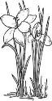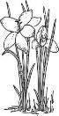

K

L M

* 1. What does the above diagram represent?
  2. Name the layers marked **L** and **M**.

L M

* 1. Why is layer marked **K** good for plant growth?

1. (a) How do the following animals move?
2. giraffe
3. an eagle
4. Why do animals move from one place to another?
5. Write down any **one** food that can be given to hens.
6. **The picture below shows items found in a bedroom.**

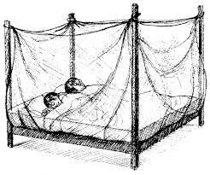

E

F

* 1. Name the item marked **E** and **F**.

E F

* 1. Name the vector controlled by structure **E**?
  2. Which disease is controlled by using item **E**?

1. (a) Give any **two** reasons why people eat food.

(b) How can food get dirty?



|  |
| --- |
| **PAPER 5** |
| **SECTION A**   1. **Which domestic animal lives in a sty?** 2. **How is wind useful to people?** 3. **Why do people plant short grass in their compounds?** 4. **Identify any one material used to make the tool below.**   C:\Users\pc\Desktop\download.jpg   1. **Give the importance of a house to people.** 2. **Give any one use of electricity at home.**   **The diagram below shows two balloons. Use it to answer question 7.**  **balloon with air**  **balloon without air** |



1. **Why did the balloon with air go down?**

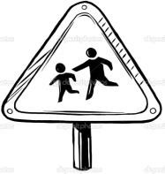

1. **Give one way of caring for a baby at home.**
2. **How can a P.3 child promote personal hygiene?**
3. **Write one way of keeping food safe for a long time.**
4. **Which food value is mainly obtained from fruits?**
5. **Give one way of caring for water sources.**
6. **What problem can be faced by people who don’t want to brush their teeth?**
7. **How are swamps useful in our environment?**
8. **What does the sign post below mean?**
9. **Why do people need health centres in their communities?**
10. **Name the second stage in the growth of a cockroach.**
11. **Which immunisable disease makes children to get skin rash?**
12. **How can a P.3 pupil ensure proper disposal of rubbish in a class?**
13. **Give an example of anything that can make a shadow.**
14. **Write the use of a knife to people.**
15. **Name one organism which helps to aerate soil.**
16. **Give any one member who can join a nuclear family to make it extended.**
17. **Why do people carry umbrellas on rainy days?**

The diagram below shows an animal. Use it to answer the question below.

1. 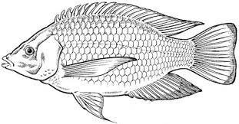**How is water useful to the animal above?**
2. **Give any one type of soil.**
3. **Apart from nimbus clouds, give any other type of clouds.**
4. **Name one part of a school which can be cleaned by scrubbing.**
5. **Write one food stuff which needs pounding in a mortar before cooking.**
6. **Why does a chameleon change its colours?**
7. **Give one method of killing mosquitoes at home.**
8. **Draw any one garden tool.**
9. **Write any one source of food.**
10. **Why do animals move from one place to another?**
11. **Give any one people made change in the environment.**
12. **Name one item that can be used to cut hair.**
13. **Which problem can a person get if his ears stop working?**
14. **Name one material we can use to catch fish.**



1. **Identify any one way animals care for their young ones.**

The diagram below shows a house. Use it to answer question 40.

# X

1. **Name part X.**

SECTION B.

1. **a) Which component of air is used in fire extinguishers?**
2. **Write any two other gases found in air.**

5. **Give one danger of air to people.**
6. **a) Name two materials used to mulch a garden.**
   1. **_**

(b) Give two importance of mulching a garden.

3. **The diagram below shows a common tool.**



1. **Name the tool shown above.**
2. **How is the above tool useful to people?**

5. **Give the danger that can be caused by the tool above.**
6. **a) Give any two uses of trees to people.**
7. **Name one animal which lives in trees.**
8. **Name any one tree that gives us fruits.**
9. **a) From which material are bricks made?**
10. **Give any one use of bricks.**
11. **Name two things used to make a roof of a house.**

14. **a) What is a balanced diet?**
15. **Give two uses of food in our bodies.**

18. **State one danger of poor feeding.**
19. **a) Name two items used to cook food.**

b) Give two ways of caring for utensils in the kitchen.

3. **a) What is sanitation?**
4. **Draw these items used to promote sanitation.**

|  |  |
| --- | --- |
|  |  |
| **broom** | **rake** |

1. **Write any one danger of poor sanitation.**



1. **a) How is a sickbay useful to a primary three pupil?**
2. **Name any one person who works in a sickbay.**
3. **Write one item found in a sick bay.**
4. **Why should a sickbay be kept clean?**
5. **a) Name any two places where wild animals live. (i)**

(ii)

1. **How are wild animals useful to people?**
2. house and sun**Write one danger of wild animals to people.**



**D**

1. **The diagram below shows the water cycle. Use it to answer question 50.**

B

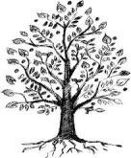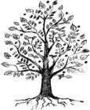

**C**

**A**

1. **Name the processes taking place at A and D.**
2. **A**
3. **D**
4. **Name part B.**
5. **How is part B important in the cycle above?**
6. **a) What is first aid?**
7. **Give any two accidents that need first aid. (i)**

(ii)

1. **Give any one reason for giving first aid.**
2. **a) How are shadows formed?**
3. **Give two uses of shadows to people. (i)**

(ii)

1. **At what time of the day are shadows shortest?**
2. **(a) Match the insects to the diseases they spread.**
   1. **Houseflies sleeping sickness**
   2. **Anopheles mosquitoes Trachoma**
   3. **Tsetse flies malaria**
3. **House flies**

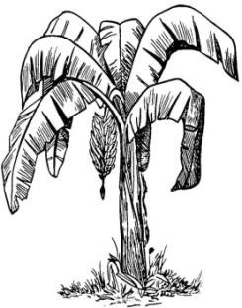

1. **Anopheles mosquitoes**
2. **Tsetse flies**

(b) Which person in our community treats a child who gets diseases?

1. **The diagram below shows a common plant.**

~~X~~

1. **Name the plant shown above.**
2. **How is part X useful to the plant?**
3. **Write one use of part X to people.**
4. **Name the garden tool used to harvest the above plant.**

|  |
| --- |
| **PAPER 6** |
| **SECTION A:**   1. **Name any one material used to keep the house clean.** 2. **The diagram below shows a soil profile.**   **K**  **Name the layer of soil marked K.**   1. **Why can’t an ostrich fly yet it has feathers on its body?** 2. **Name any one disease that has no cure.** 3. **Why are people encouraged to boil water for drinking?** 4. **Identify any one food stuff rich in proteins.** 5. **Give one effect of charcoal burning to the environment.** 6. **Write down one natural source of energy.** |



1. **Name a disease which can be controlled by sleeping under a mosquito net.**



**How is the part shown in the diagram useful to a plant?**

**Give any one example of a fuel commonly used at home.**

1. **Why do people plant grass in the school compound?**
2. **How can you prevent a water source like a well from contamination?**
3. **Give an example of a disease which can be controlled by immunization.**
4. **Which body part do you use to taste food?**
5. **How is heavy rainfall dangerous in our environment?**
6. **To which body part of an insect are the legs attached?**
7. **Why is a stone considered to be a non living thing?**
8. **Name any one example of a wild bird.**
9. **Write one way we can save resources at home.**
10. **Identify the part of a sugarcane plant that stores food.**
11. **Why do we cook food before eating it?**
12. **How is a shadow useful to people?**
13. **Identify any one common accident at home.**
14. **Name any one element of weather.**
15. **Give one use of things like toy cars made from artificial materials.**
16. **Give any one role of a father at home.**
17. **How is the garden tool below useful to a farmer?**

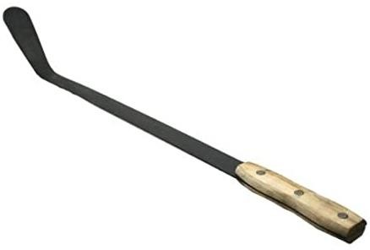



1. **Name any one item used to manage rainy weather.**
2. **How are floods dangerous in the environment?**
3. **How is a watering can useful to a farmer in a dry season?**
4. **Why is carbon dioxide used in fire extinguishers?**
5. **Write any one PIASCY message.**
6. **State any one way a P.3 child can control the spread of malaria at home.**
7. **In the space below, draw the animal that guards our home.**
8. **Which accident will come as a result of playing with the object below.**
9. **Give one reason why people make mats.**
10. **Why is it advisable to brush our teeth after every meal?**
11. **Mention any one animal kept in an aquarium.**
12. **The diagram below shows a sick child.**

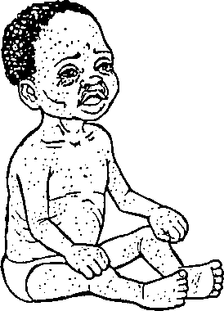

Identify the immunisable disease the above child is suffering from.

SECTION B

1. **a) What is a balanced diet?**
2. **Mention two classes of food that make up a balanced diet.**

5. **How is poor feeding dangerous to children?**
6. **(a) What are domestic animals.**

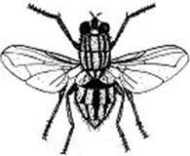

1. **Give two examples of domestic animals that are kept for transport.**

4. **How is a cow useful at home?**
5. **The diagram below shows the life cycle of a housefly. Use it to answer questions that follow.**

M P

O

Adult

1. **Name the stage marked O and P.**

O P

1. **How is the adult stage of a housefly dangerous to people?**
2. **Use the diagram below to answer questions that follow.**

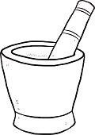

Y

* 1. **Identify the tool marked Y.**
  2. **How is the above tool useful to people at home?**
  3. **Name any two food stuffs prepared in the above tool.**

3. **a) Write down any one item / tool needed to do the following;**
4. **Milking**
5. **Farming**
6. **Fishing**

b) Why do people carry out such activities in their community?

1. **a) How is HIV / AIDS dangerous to people?**
2. **Write two ways we can care for AIDS patients.**

5. **Give any one way we can prevent the spread of AIDS.**
6. **a) How is soil formed?**
7. **Give any two types of soil.**

10. **Identify the component of soil that makes it fertile.**
11. **a) How many legs has an insect?**

b) Why are termites and bees referred to as social insects?

b) Mention two ways in which insects are useful to people.

3. **Match the materials used to clean the body correctly to their uses. Material Use**

Tooth brush scrubbing dirt from the body.

Soap brushing teeth.

Sponge removing wax from ears.

Ear bud kill germs on the skin.

* 1. **Tooth brush**
  2. **Soap**
  3. **Sponge**
  4. **Ear bud**

1. **How are the following road signs useful to road users? (i)**

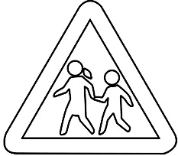

(ii)

b) Identify the colour of the traffic lights that;

1. **Lets the vehicles to move**
2. **Stops the vehicles**
3. **a) How are doctors and nurses useful in our sub-country?**
4. **Name any one place where doctors and nurses work.**
5. **What special name is given to the vehicle that transports people who have got accidents to the hospital?**
6. **Name any one hospital you know in Uganda.**
7. **a) What is weather?**
8. **How are the following elements of weather useful to people;**
9. **Sunshine -**
10. **Rainfall -**
11. **State the importance of the sun in a water cycle.**

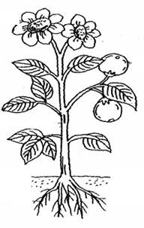

1. **Below is a diagram of flowering plant, use it to answer the questions that follow.**

A

B

C

* 1. **Name parts labelled A and C.**

A B

C

* 1. **Use letter T to show the part that makes food for the plant.**

1. **What is First aid?**
2. **Give two reasons why we give first aid.**

5. **Identify any one place where we find a first aid box.**
6. **Use the words below to fill the gaps correctly.**

diarrhoeal diseases , rakes , scrubbing , sanitation

is the general cleanliness of our environment. We can keep places clean by sweeping, slashing, mopping and

.

We use tools like brooms, slashers, rags and

to keep our environment clean. People practice good sanitation to prevent .

|  |
| --- |
| **PAPER 7** |
| **SECTION A (40 marks)**   1. Name any **one** animal kept at home. 2. Give any **one** way of preventing accidents at home. 3. How can you keep your body clean**?**   **The picture shows a wild animal.**     1. Name the animal shown above. 2. How do birds move from one place to another**?** 3. Name any **one** food we get from animals. 4. Name any **one** fruit crop in your school compound. 5. How are insects useful in our community**?** |

1. Identify any **one** component of soil.
2. Name any **one** thing a plant needs to grow well.
3. Give any **one** activity carried out by farmers during the wet season.
4. Draw any **one** item made from banana fibres.
5. How can a P.3 child manage rainy weather**?**
6. How is the sun important to people**?**
7. Which human body organ is used for smelling**?**
8. Give any **one** way of controlling soil erosion.
9. Draw any **one** material you can use to clean your body.
10. How are dust bins useful in our classrooms**?**
11. What is the use of food in your body**?**

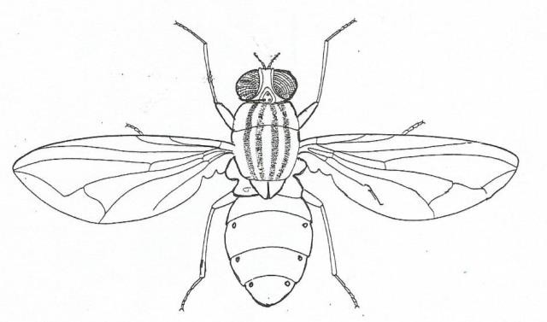

1. How does a dog protect itself against its enemies**?**
2. Which type of soil has the biggest soil particles**?**
3. Identify any **one** common accident at home.
4. Name any **one** insect that lives in soil.
5. Identify any **one** use of cats at home.
6. How is humus formed**?**
7. Identify any **one** item used for clearing bushes around our school.
8. The diagram below is of an insect. Name part marked **X**.

Y

X

X

1. What is the use of the part marked **Y** to the insect**?**
2. Give the importance of keeping food safe.
3. How can you care for plants**?**

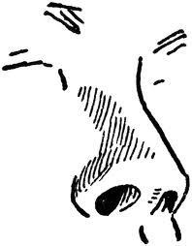

1. Give the use of the garden tool shown below.

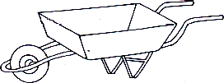

1. Why is the third layer of a soil profile not good for crop growing**?**

The diagram below shows a human sense organ.

1. Identify the sense organ shown above.
2. Give any **one** material people can use to make balls.
3. Give any **one** insect which protects its self by stinging**?**
4. Why do people brush their teeth every after a meal**?**
5. Which type of family has parents and biological children only**?**
6. How can a dog be dangerous to people**?**
7. Name any **one** immunisable childhood disease.
8. Give any **one** danger of putting on dirty clothes.

SECTION B (60 MARKS)

1. (a) Briefly explain the meaning of first aid.
2. State any **one** reason for giving first aid.
3. Draw and name **two** items used in giving first aid.

|  |  |
| --- | --- |
|  |  |
|  |  |

1. (a) Apart from hides, mention any **one** other product got from a cow.
2. Give any **one** way of caring for cows at home.
3. Draw these items made from animal hides.

|  |  |
| --- | --- |
|  |  |
| drum | belt |

1. **Below is a flowering plant, use it to answer questions that follow.**

# P

**Q**

# T

**S**

# R

* 1. Name the parts marked **T** and **S**.
     1. **T**
     2. **S**
  2. Give the function of parts marked **P** and **R**.

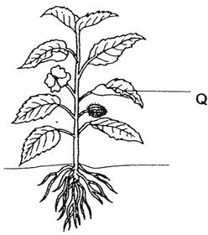

* + 1. **P**
    2. **R**

1. **Match the animals to their weapons correctly.**

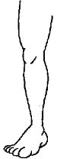

Animal weapon

* 1. goat claws
  2. bee hands
  3. person horns
  4. cat sting

prickly hair

1. goat
2. bee
3. person
4. cat
5. **The diagrams below shows types soil.**

A B C

|  |  |  |
| --- | --- | --- |
|  |  |  |

* 1. Name the type of soil marked with letters **A**, **B** and **C**.
     1. **A**
     2. **B**
     3. **C**
  2. Which letter shows the type of soil which allows water to pass through easily**?**

1. **The diagram below shows part of the human body.**
   1. Name the part shown above.

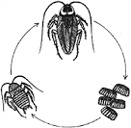

* 1. Give the use of the part shown above to people.
  2. How do you care for that part**?**
  3. Write any one thing used in cleaning the above part of the body.

1. **Study the life cycle of a cockroach.**

Y

nymph X

* 1. Name these stages.
     1. **X** (ii) **Y**
  2. Mention any **two** diseases spread by the insect above.

1. (a) Name any **two** places where you can be taken when you are sick.

(i) (ii)

1. Write the use of water to a first aider.

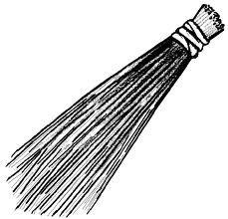

1. Name the items below that are used by first aiders.
2. (a) How can you use these things for keeping your bedroom clean**?**

# B

**A**

1. **A**
2. **B** 
   1. Why do people keep their homes clean**?**
3. Draw a tool used for cutting grass.
4. (a) Identify any **two** wild animals.

(i) (ii)

* 1. State the homes of these animals

1. Fish



1. Monkey
2. **The diagram below shows a house**.

**X**

**R**

* 1. Name the parts marked **X** and **R**.
     1. **X** (ii)

R

* 1. Write any **two** things used when building a house.

(i) (ii)

1. (a) Name any **one** type of family in your village.

(b) Give any **one** role of the following people in a family.

1. child
2. mother
3. father
4. Name the young ones of the animals below.
   1. Cow
   2. Goat
   3. Dog
   4. Cat
5. (a) In **one** sentence, give the meaning of the word weather.
6. Write any **two** elements of weather.

9. Which type of weather is managed by using an umbrella**?**
10. (a) Name any **two** food stuffs eaten at home.

(b) Write any **two** use of food in the human body.



|  |
| --- |
| **PAPER 8** |
| **SECTION A**   1. **Name any one domestic animal with horns.** 2. **How are ears useful to a P.3 child?** 3. **Why is it not good to cross the road carelessly?** 4. **How is a sting useful to a bee?** 5. **Name any one animal which uses a nest as its habitat.** 6. **Why is a fire extinguisher painted with bright colours?** 7. **How can we protect our bodies from catching skin diseases?** 8. **Why should farmers mulch their gardens?** 9. **How is the plant below harmful to people?**      1. **Name the sense organ for tasting.** |

1. **Why is a grasshopper grouped under insects?**
2. **Write any one common accident at home.**
3. **Complete the diagram to form the shadow.**



1. **Why should a home have a dust bin?**
2. **Why do dogs bark at strangers in our homes?**
3. **How can we prevent soap from spreading into eyes when bathing?**
4. **Which part of a cassava plant do people eat?**
5. **Name any one method of preserving food.**
6. **Why do we give first aid to casualties?**
7. **How are wild animals useful to people?**
8. **Write down any one effect of accidents to people.**



1. **Draw one item used to manage rainy weather.**
2. **Give one use of trees in our school compound.**
3. **Give any one use of clay at home.**
4. **Name any one pest.**
5. **Give one way you can care for your eyes.**
6. **Why do animals like chameleons change colour?**
7. **Name the property of air shown in the diagram below.**

deflated balloon

Inflated balloon

1. **How is poor feeding dangerous to children?**
2. **Why should people sleep under mosquito nets?**
3. **Give one use of leaves to a plant.**
4. **Identify one member of an extended family who is not found in a nuclear family.**
5. **Why are children taken for immunisation?**
6. **Give one non-curable disease.**
7. **How is a knife useful in a kitchen?**
8. **Give one use of food to the body.**
9. **State any one product got from cows.**
10. **How are spiracles useful to an insect?**
11. **Draw one object used in the cleaning of our teeth.**
12. **Give one use of a beak to a bird.**

SECTION B

1. **Below are diagrams of animals.**

|  |  |
| --- | --- |
|  |  |
| **A** | **B** |

* 1. **Name animals labelled A and B.**

A B

* 1. **Give one use of animal A to us.**
  2. **Why is animal lablled B grouped under wild animals?**

1. **(a) Give one use of sunglasses to people on a sunny day.**
2. **Why are we advised to harvest cereal crops in a dry season?**
3. **Give one danger of too much rainfall to farmers.**
4. **Why should a farmer first dry cereals before storing them?**
5. **(a) What is first aid?**
6. **State any two importance of first aid. (i)**

(ii)

1. **Name any one sharp object that can cause harm to the body.**
2. **(a) Name any two common diseases in our sub-county.**

(b) Give any two ways of preventing common diseases. (i)

(ii)

1. **Below is a diagram of soil profile.**

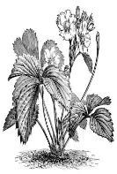

A

B

C

* 1. **Name soil layers A and B.**

1. **A**
2. **B** 
   1. **Give any one way on which soil is formed.**
   2. **State one way of keeping soil fertile.**
3. **(a) Name any one item used to trim finger nails.**
4. **Give one reason why we should brush our teeth after every meal.**
5. **Name these items used in keeping our bodies clean.**

|  |  |
| --- | --- |
| Image result for local plant sponge used for bathing |  |
|  |  |

1. **Arrange the following sentences in their correct order.**
2. **The clouds become heavy and fall as rain.**
3. **The sun heats water in the water body.**
4. **The water vapour condenses to form nimbus clouds.**
5. **The water evaporates in to the atmosphere. Correct order.**

1.

2.

3.

4.

1. **(a) Name any two objects made out of local materials.**

(b) Identify any two local materials used to make local objects.

3. **Below is a diagram of a garden tool.**



* 1. **Identify the above garden tool.**
  2. **How is the above garden tool useful to a farmer?**
  3. **How can we take care of the above garden tool?**

3. **Match A with B correctly.**
4. **- cow , pig , lion , dog**
5. **- kennel , den , pigsty , byre A B**

Cow

Pig

Lion

Dog

1. **(a) Name any two common insects.**

(b) Give two uses of insects to people.

(i)

(ii)



1. **(a) Why do we eat food?**
2. **Why should some food be cooked before eating it?**
3. **What is the best food for babies of one month?**
4. **Name one class of food.**
5. **The diagram below shows materials used in the preparation of food stuffs.**

pestle

mortar

* 1. **Name one material used to make the above tools.**
  2. **Write any two food stuffs prepared using the above tools.**

2. 1. **Why should the above tools be kept clean?**
3. **(a) What is soil erosion?**
4. **Give any two agents of soil erosion.**

(i)



(ii)

1. **How can you control soil erosion in your home compound?**
2. **The diagram below shows one of the materials in a first aid box.**
   1. **Identify the material shown above.**
   2. **How is the above material useful to people?**
   3. **Identify any one accident which can be caused by carelessly using the above material.**
   4. **Give the use of a first aid box to a first aider.**

|  |
| --- |
| **PAPER 9** |
| **SECTION A:**   1. **Name one material which can be made from sisal.** 2. **The diagram below shows a soil profile.**   **W**  **Name the layer of soil marked W.**   1. **Identify one danger of heavy rainfall in the environment.** 2. **What is the use of brooms in our classes?** 3. **Write down one common characteristic of insects.** 4. **Identify any one group of people who help in traffic.** 5. **Give one danger of cutting down many trees in the environment.** |



1. **The diagram below shows a home of an animal.**

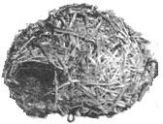

Name it

1. **Give one common fuel used for cooking at home.**
2. **Why is it dangerous to play near a cooking place?**
3. **Name the main body part of an insect on which the legs are attached.**
4. **How can we prevent food from getting contaminated?**
5. **Why do we wash our hands after picking rubbish?**
6. **Why is a spider not considered to be an insect?**
7. **How can farmers control soil erosion in their gardens?**
8. **Identify any one good health practice you know.**
9. **How is a zebra crossing useful to pedestrians?**
10. **Identify any one danger of diarrhoea to a patient.**
11. **Why is clay soil the best soil to use when making pots?**
12. 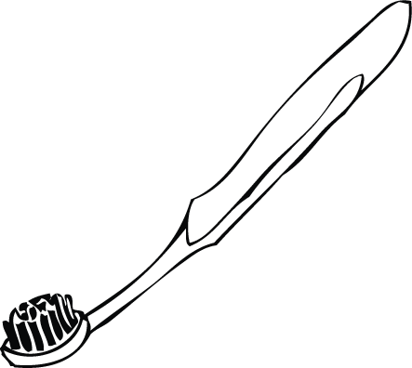**How is the item below useful in promoting personal hygiene?**
13. **Write any one property of air.**
14. **Why do farmers spray crops in the garden?**
15. **Why do farmers keep garden tools in a cool dry place?**
16. **How is a toilet useful to people?**
17. **Name any one childhood immunisable disease.**
18. **Identify any one source of food.**
19. **Name any one item we use in the kitchen.**
20. **In which way are strong winds dangerous to plants?**
21. **How is water useful during germination?**

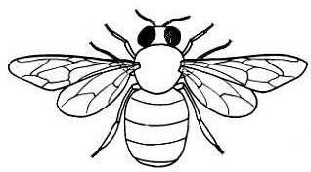

1. **In which one way is oxygen gas useful to people?**
2. **Give one way people can care for their eyes.**
3. **Draw and name one material made from banana fibres.**
4. **How can a P.3 pupil help to control the spread of malaria at home?**
5. **State one way of keeping food safe.**
6. **How are parts marked X useful to an insect?**

X

1. **Name any one item at home used for grinding millet.**
2. **Give one way we can keep ourselves safe from accidents at home.**
3. **Why do animals move from one place to another?**
4. **Why is an antelope grouped under living things?**
5. **Identify any one reason why people make mats.**

SECTION B

1. **a) What is an accident?**
2. **Name one cause of accidents on the road.**
3. **Write any two effects of an accident to a person.**

6. **a) Apart from air , name one component of the environment.**
7. **In which way is the component of air with 0.03% useful to plants?**
8. **Write down any two properties of air.**


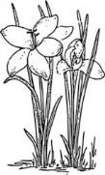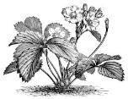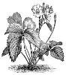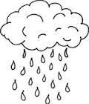

1. **What is wind?**
2. **Apart from wind, name two elements of weather.**

5. **State any one way of managing rainy weather.**
6. **Study the diagram below shows a natural process.**

R

Q

* 1. **Name the cycle shown above.**
  2. **How is the sun useful in the above process?**
  3. **Name the process taking place at Q.**
  4. **Which clouds give us rain?**

1. **a) Give any one use of food in the body.**
2. **State any one danger of poor feeding.**
3. **Mention any two sources of food in your division / subcounty. (i)**

(ii)

1. 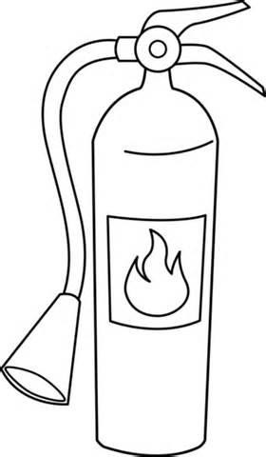**Use the diagram below to answer questions that follow.**
   1. **Identify the above item.**
   2. **Give one use of the above item in a school.**
   3. **Name the part of air found in the item above.**
   4. **Who in a school can use the above item?**
2. **a) Why is a duck grouped as a domestic bird?**
3. **Apart from a duck, name one other example of a domestic**

bird.

1. **Give any two uses of domestic birds to people. (i)**

(ii)

1. **a) What is a family?**
2. **Identify any one type of a family.**
3. **Name any two members of family.**

6. **a) How are the following types of soil useful in your division?**
7. **sand**
8. **clay**
9. **Mention any one organism that stays in soil.**
10. **Why is loam soil the best for plant growth?**
11. **a) How is the sun useful in the environment?**
12. **Give one danger of the sun.**
13. **Which type of weather is best for the following human activities?**

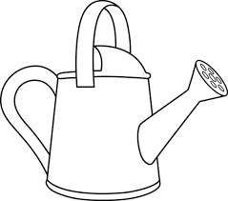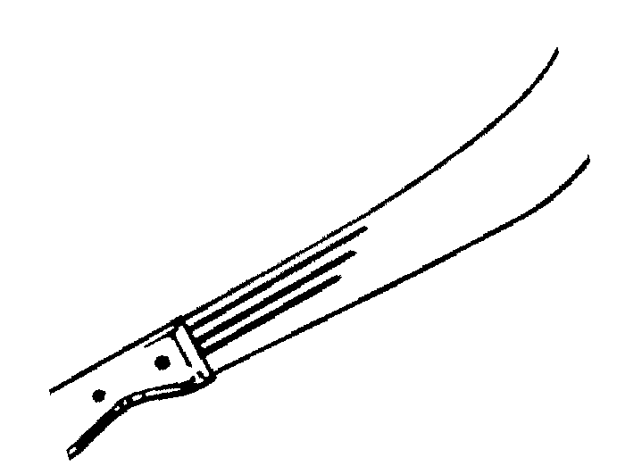

1. **Winnowing seeds**
2. **Drying harvested crops**
3. **Below are some of the garden tools. Use them to answer the questions that follow.**

A B C D

* 1. **Name the garden tool labelled D.**
  2. **How are the garden tools labelled A and C useful to farmers?**

1. **Garden tool A**
2. **Garden tool B**
3. **Garden tool C**
4. **a) What are domestic animals?**
5. **Which domestic animal is kept for wool production?**
6. **Identify any one product made from skins or hides.**

c) How are animal wastes useful to farmers?

1. **Match correctly.**

Fish Walking

Snake Jumping

Frog Swimming

Man Slithering

Fish Snake

Frog Man

1. **What is First aid?**
2. **Mention any two reasons why we give first aid.**

5. **Name any one item used in giving First aid.**
6. **Name any two childhood immunisable diseases.**

9. **Identify any one place where children are taken for immunization.**
10. **Mention one group of people who carry out immunization.**

|  |
| --- |
| **PAPER 10** |
| **SECTION A. (40 Marks)**   1. **Name any one useful insect.** 2. **Why does a leopard move from one place to another?** 3. **How is a toilet useful in a school?** 4. **Why is a cockroach grouped under insects?** 5. **Give one danger of growing crops near anthills.** 6. **Draw the part of a plant used to make food.** 7. **Name any one childhood immunisable disease.** 8. **During what time of the day are shadows shortest?** 9. **In the space below, draw and name one item made from animal skin.** |

|  |  |  |
| --- | --- | --- |
|  |  |  |
|  |
| 1. **How is a dog useful in a home?** 2. **Give the use of a beak to a hen.** 3. **What is soil erosion?** 4. **Write one use of mulching a garden.** 5. **Apart from mulching, how else can you care for crops in the garden?** 6. **Why is an ostrich unable to fly?** 7. **How are floods dangerous in an area?** 8. **Why are pedestrians advised to cross a busy road at a zebra crossing?** 9. **Give one danger of poor feeding to a child.** | | |

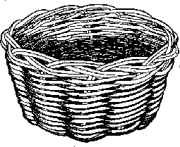

1. **Write any one source of food.**
2. **Why is loam soil the best for crop growing?**
3. **How are nimbus clouds important in our sub-county?**
4. **Name the main natural source of heat and light.**
5. **How is water important in a kitchen?**

The diagram below shows a local tool.

1. **Give any one use of the tool above to a crop farmer.**
2. **Which component of air helps a candle to burn?**
3. **How can farmers control pests in the garden?**
4. **What is the best season for planting seeds?**
5. **Why should children not play near sharp objects?**

The diagram below shows an item kept in a first aid box.

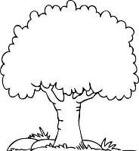

1. **Give the use of the above item to people.**
2. **How can people care for domestic animals at home?**
3. **Name any one crop grown in the swamps.**
4. **Name one type of life cycle.**
5. **How is a rain gauge useful at a weather station?**
6. **Draw the shadow formed correctly.**
7. **Name one item that can be used to keep the environment clean.**
8. **Why do fish move from one side of a river to another?**
9. **Name any one element of weather.**

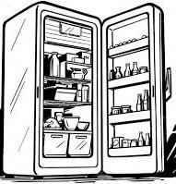

1. **Write any one way of controlling malaria at home.**
2. **State any one time when you are supposed to wash hands.**
3. **Give any one example of a fruit.**

SECTION B

1. **Below is an instrument used to preserve food.**
   1. **Identity the above instrument.**
   2. **Name any two food stuffs preserved in the above instrument.**
3. 1. **Why is food preserved?**
4. **(a) What is air?**

(b) Write any two components of air. (i)

(ii)



(b) Give any one property of air.

1. **The diagram below shows a body organ. Use it to answer question 43.**
   1. **Name the above body organ.**
   2. **Apart from the above organ, name one other body organ.**
   3. **Identify any one disease that affects the above organ.**
   4. **How can we take care of the above organ?**
2. **(a) Why is a maize plant referred to as a flowering plant?**
3. **Give two uses of leaves to plants. (i)**

(ii)

1. **Why do plants with weak stems climb others?**
2. **(a) What is an accident?**
3. **Name any two common accidents. (i)**

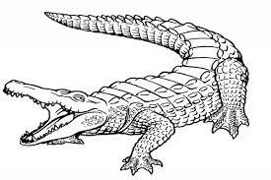

(ii)

1. **How do you help a friend who has got an accident?**
2. **Use the diagram below to answer questions that follow.**
   1. **Identify the above wild animal.**
   2. **What does the above animal use to hold its food?**
   3. **Give the danger of the above animal to people.**
   4. **Write any one use of the above animal to people.**
3. **(a) Why do people need a balanced diet?**
4. **Why do we eat food?**
5. **Why is it dangerous to eat food with unwashed hands?**
6. **Name one disease that is a result of poor feeding?**
7. **(a) Why do people need a toothbrush?**
8. **Why should we bathe daily?**
9. **Give the use of ironing clothes.**
10. **Why is it dangerous to wear dirty clothes?**
11. **Use the diagram below to answer questions that follow.**
    1. **Identify the above garden tool.**
    2. 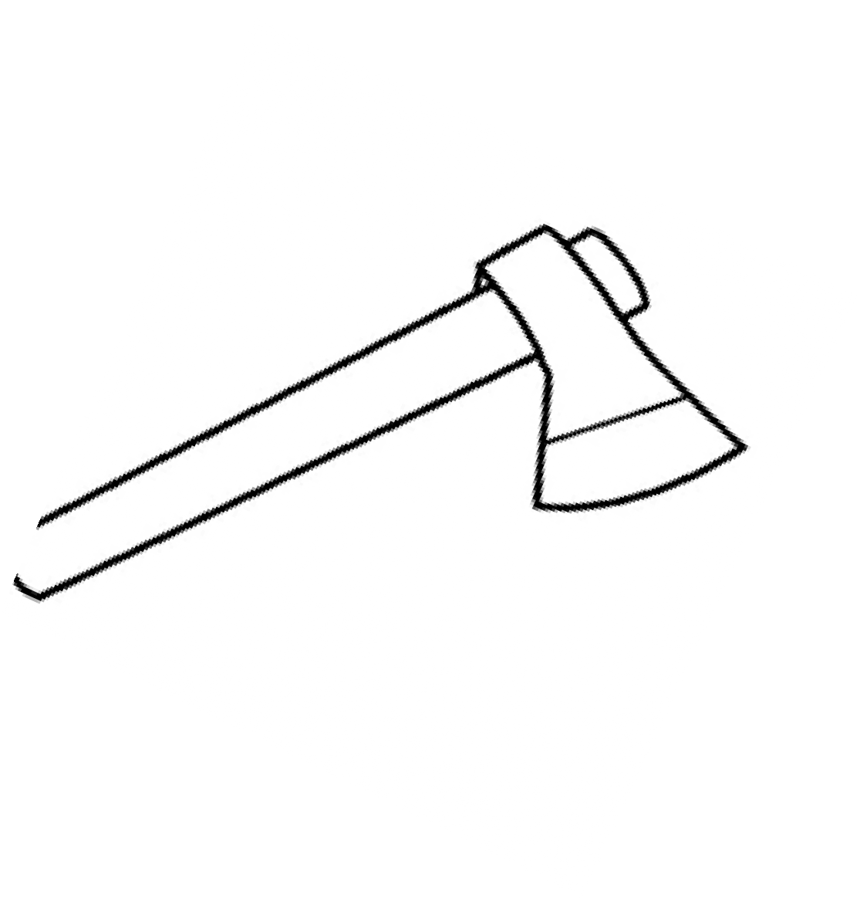**How is the above garden tool important to a farmer?**
    3. **How can we take care of the garden tool above?**

14. **(a) Write one item you can use to protect yourself from sunny weather.**
15. **How is wind useful to a farmer?**
16. **How is too much rainfall dangerous in an area?**

19. **(a) Why are children taken for immunization?**
20. **The pictures below show children suffering from immunization diseases.**

|  |  |
| --- | --- |
| **A** | **B** |

1. **Identify the disease the above children are suffering from.**

A B

1. **How can the above diseases be controlled?**
2. **(a) Name two items used in the kitchen to cook food.**

(b) Give two ways of caring for the items found in the kitchen.

(i)



(ii)

1. **Use the diagram below to answer questions that follow.**
   1. **Name the soil animal above.**
   2. **How is it useful to soil?**
   3. **Apart from the animal above, name one other component of soil.**
   4. **How can farmers maintain soil fertility?**
2. **Match correctly.**

A B

Slithering grasshopper

Flying fish

Swimming snake

Hopping bird

|  |  |  |
| --- | --- | --- |
| **(a)** | **Flying** |  |
| **(b)** | **Hopping** |  |
| **(c)** | **Slithering** |  |
| **(d)** | **Swimming** |  |

|  |  |
| --- | --- |
| **55. (a)** | **Write any two common diseases.** |
| **(i)** |  |
| **(ii)** |  |
| **(b)** | **How can we prevent malaria in our homes?** |
| **(i)** |  |
| **(ii)** |  |

|  |
| --- |
| **PAPER 11** |
| **SECTION A. (40 MARKS)**   1. Name the body organ for smelling. 2. How is the item below useful to people.   Description: Related image   1. Give **one** role of a mother at home. 2. How is a zebra crossing useful to pedestrians? 3. Write down **one** danger of too much sunshine in the environment. 4. State **one** way you can make use of banana fibres at home. 5. What is the main source of light energy in our environment? 6. How does a chameleon protect itself? 7. **The diagram below shows a garden tool.** |



How is the above tool useful to farmers?

1. Give any **one** danger of accidents to the human body?
2. Write any **one** activity you can do to keep your bedroom clean.
3. Give any **one** example of an object that can float on water.
4. What do we call the meal that contains all food values in their correct amount?
5. How can you prevent milk from going bad at home?
6. How are earthworms useful in the soil?
7. Write down **one** common disease which has no cure.
8. How are wild animals dangerous to people?
9. Give **one** way of caring for crops in the garden.
10. Name any **one** component of air.
11. How are nimbus clouds useful to crop farmers?
12. **In the space below, draw a domestic animal with two legs.**

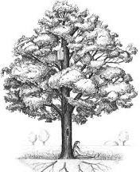

1. What is the first aid for nose bleed?
2. Name any **one** item that can be used in the kitchen.
3. **Complete by drawing a shadow**.
4. Why is carbondioxide used in a fire extinguisher?
5. How can you make water safe for drinking at home?
6. How can we care for domestic birds?
7. Name any **one** animal that lives in water.
8. Give any **one** basic need of people.
9. How can you assist a friend who is sick at school?
10. Give **one** way people can use harvested water at home.
11. Name the food stuff made by bees.
12. Name any **one** element of weather.
13. How are trees useful in a school compound?
14. Give **one** way of keeping the environment safe.
15. How is a housefly dangerous to people?
16. What is soil profile?
17. How is a latrine useful at home?
18. Write down **one** importance of trees.
19. **Draw a garden tool that can be used for harvesting bananas and sugarcanes.**

SECTION B

1. a) Mention any **two** sources of water.

b) State any **two** use of water to people.

3. a) Name any **two** immunizable diseases.
4. Write any **one** place where immunization can be carried out.
5. Identify any **one** group of people who immunize children.
6. a) What is mulching?
7. Why do farmers mulch their gardens?

10. Give **one** example of a material that can be used for mulching.
11. **a) Match the animals to their habitats correctly.**

Animal habitat

* 1. cow cobweb
  2. lion anthill
  3. spider den
  4. termite byre

Animal habitat

1. cow
2. spider
3. lion
4. spider
5. a) How is soil erosion dangerous in the garden?
6. How can farmers control soil erosion in;
7. school compound?
8. hilly areas?
9. State **one** danger of soil erosion.
10. **The diagram below shows an insect. Use it to answer questions that**

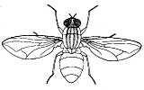

follow.

X

Z

Y

Y

1. Name the part labeled **Y**.
2. How are parts marked **X** and **Z** useful to an insect?

X Z

1. By use of an arrow, show and name the thorax.
2. **a) Group the foodstuffs below into their classes of food**

***cassava beans rice meat***

|  |  |  |
| --- | --- | --- |
| Go food |  |  |
| Grow food |  |  |

1. a) Mention any **two** common accidents at home.
2. Write any **one** cause of accidents at school.
3. What do we call a person who has got an accident?



1. **Identify the domestic animals.**

|  |  |
| --- | --- |
| Description: http://cdn.lookanimals.com/pictures/www.printactivities.com/ColoringPages/Farm-Animal-Coloring-Pages/Sheep-1.gif | Description: http://www.bestcoloringpagesforkids.com/wp-content/uploads/2013/07/Camel-Pictures-Coloring-Pages.gif |
|  |  |

b) How are the above animals useful to people?

3. a) What is air?
4. Which component of air is needed for ;
5. fire extinguishing -
6. burning
7. Identify the property of air shown in the diagram below.

deflated balloon

inflated balloon

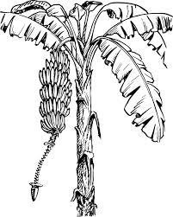

1. a) Why do we preserve food?

b) How can people in villages preserve the following foods?

1. beans –
2. fish –
3. ground nuts -
4. **Study the diagram of a plant below.**

K

1. Identify the plant shown above.
2. Name the part marked **K**.
3. How is part marked **K** useful to people?
4. How can you care for the above plant?
5. a) Write down any **two** dangers of poor feeding.

b) Give any **two** signs of a child who does not feed well.

3. a) Give **one** example of each of the following insects.
   1. useful insects
   2. harmful insects

b) Name the uses of birds to people.

3. a) Name **one** thing we make at school for playing.
4. Mention the material from which it is made.
5. Where can we get the material in (b) above?
6. Apart from playing, give **one** importance of the things we make at school.

|  |
| --- |
| **PAPER 12** |
| **SECTION A (40 Marks)**   1. What term is used to mean the study of living things and non-living things? 2. Name the main natural source of water. 3. What is an accident? 4. Why do we wash our hands with clean water and soap? 5. Which type of soil is good for growing crops? 6. Name the habitat for this animal.      1. Why do animals move from one place to another? 2. Give **one** importance of air. 3. Which clouds give us rain? 4. Mention **one** type of weather. 5. How are bees important to man? 6. Which type of accident is most likely to happen to you if you play with fire? |
|  |



1. What property of air is shown below?
2. Name the type of air we breathe in.
3. Mention any **one** layer of soil.
4. Give **one** way we can keep our environment clean.
5. Name any **one** example of a natural change.
6. Why do we boil drinking water?
7. Which part of air is used to preserve soft drinks like soda?
8. Mention any **one** common disease you know.
9. Give **one** component of the environment.
10. Draw and name **one** product got from clay.
11. Name any **one** wild animal you know.
12. What is wind?



1. Which sense organ is used for smelling
2. Name any **one** plant you know.
3. What is formed when plants and animals decay?
4. Name any **one** animal used for transport.
5. What are living things?
6. Give **one** example of food you eat at school.
7. What do insects use for breathing?
8. Why do we cut our finger nails short?
9. Name this garden tool.
10. What part of air occupies the biggest percentage in the atmosphere?
11. What is the meaning of **‘environment?**
12. Name the process by which rock particles are broken up into smaller particles.

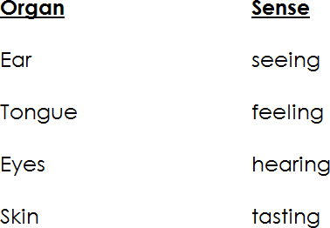

1. Identify by circling the non-living thing from the list below.
   * cat
   * dog
   * car
   * maize plant
2. Give **one** example of a leguminous crop.
3. Mention any **one** building material.
4. Name the part of a bird used for eating.

# SECTION B (60 Marks)

1. Match these organs with their senses
2. Ear :
3. Tongue :
4. Eyes :
5. Skin :
6. a) Give any **two** uses of domestic animals.

9. Suggest any **one** way of caring for domestic animals.
10. Name any **one** product got from domestic animals.
    1. 43(a) List down **four** uses of water.



15. (a) State any **two** common accidents.
16. Suggest **two** ways of preventing accidents.
17. Give one product got from the following.
    1. milk :
    2. animal skins :
    3. banana fibre
    4. clay :
18. (a) Draw these items used for keeping proper sanitation.

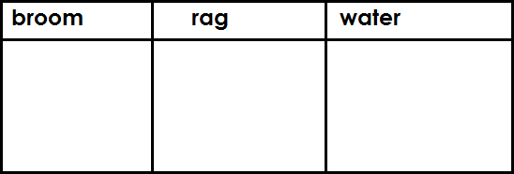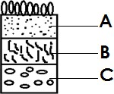

b) Why should we keep proper sanitation?

1. (a) Write down any **three** components of the environment.
2. State any **one** activity done by people to spoil the environment.

48.(a) Name the part of an insect where its legs are attached.

* 1. How many legs does an insect have?
  2. What name is given to the larva stage of a butterfly?
  3. Give **one** way a housefly is dangerous to people.

1. The diagram below is of the soil profile. Use it to answer the questions that follow.
   1. Name the layers marked;
      1. B
      2. C
   2. Why is layer A said to be the best for crop growing?

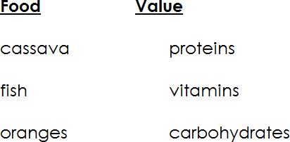

* 1. In which layer does weathering takes place?

1. (a) Match and re-write food with food values.
2. Cassava
3. Fish
4. Oranges

b) Why do we eat food?

1. (a) Give any three elements of weather.

b) Which instrument is used to measure the amount of rainfall?

52(a) What are food crops?



b) Draw and name any **three** examples of food crops.

53(a) Who is a casualty?

1. Name any **two** things found in a first aid box.
2. Why do we give first aid?
3. Complete the story below by filling in the correct word from the box.

Living are found all over the world. They are called so because they can , feed and produce

ones.

Living things are of different sizes, some are and others are very small.

1. What do you understand by the term **‘air’?**
2. Mention any **two** components of air apart from oxygen.
3. State any **one** property of air.

|  |
| --- |
| **PAPER 13** |
| **SECTION A (40 Marks)**   1. Name any **one** example of a domestic animal. 2. Give any **one** way of keeping your classroom clean. 3. State any **one** example of food eaten at home. 4. Why is loam soil best for growing crops? 5. Which body part is used for seeing? 6. Name any **one** insect eaten by people. 7. How is a charcoal stove useful at home? 8. Name any **one** road sign you know. 9. Draw this garden tool.   **hoe**   1. Write any **one** thing used for playing at school. |

1. Name any **one** example of fruits.
2. Name any **one** item found in a first aid box.
3. Write any **one** part of a plant eaten by people.
4. Mention any **one** component of soil.
5. How can you keep the toilet clean?
6. Write any **one** item used for writing.
7. Write **one** member found in an extended family.
8. State any **one** material used for building.
9. Why do animals move from one place to another?
10. Mention any **one** type of seasons.
11. What is the use of a nurse at school?
12. What name is given to the young one of a goat?
13. Name any **one** thing used to clean our hands.
14. Name the insect that spreads malaria.
15. Mention **one** example of food which gives us energy.



1. State any **one** use of soil to people.
2. Name any **one** insect that contaminates our food.
3. Name any **one** example of non-living thing found in our classroom.
4. Give any **one** example of a plant.

_

1. Which type of accident is caused by;
2. Why do we need a cook at school?
3. Mention any **one** room found in the house.
4. Why do you give birds food at home?
5. Where do you put rubbish in class?
6. State any **one** example of a living thing which lives in soil.
7. State any **one** thing used for mopping.
8. What is the use of a cup at home?

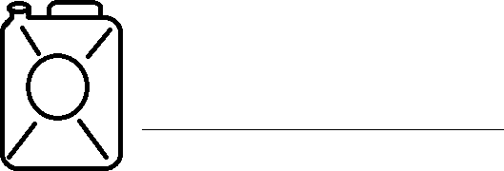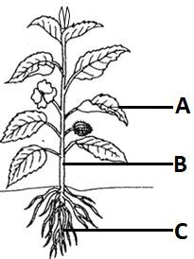

1. Mention any **one** plant grown in a garden.
2. How can you keep a school compound clean?
3. Name this material used to fetch water.

# SECTION B (60 Marks)

1. What is food?
2. State any **one** use of food in the body.
3. Mention **two** items used to cook food.
4. a) Name the parts of plant.
   1. A :
   2. B :
   3. C :

b) How can you care for plants in a garden?

43) Match List ‘A’ to list ‘B’

|  |  |
| --- | --- |
|  | for hearing |
|  | for tasting |
|  | for seeing |
|  | for smelling |

1. (a) Mention any two dangerous objects.

b) Which dangerous object can cause the following?

* 1. Cuts :
  2. Pierce : 45(a) Name any **two** examples of diseases you know.

3. Mention any **two** insects which can spread diseases.






1. (a) What is seedling?
2. Give any **two** examples of seeds grown in the garden.
3. (a) Name the materials used to make these things.
4. balls :
5. ropes:
6. mats :
7. State any **one** thing made out of timer.
8. The diagram shows the soil layers.
   1. Name the layers;
      1. A :

**A**

* + 1. B :

**B**

**C**

1. Why is layer A good for growing crops?
2. Name any **one** living thing which live in layer A.

49)

50

Draw things used to give first aid.

|  |  |  |  |
| --- | --- | --- | --- |
| **Razorblade** | **water** | **cotton wool** | **Cloth** |
|  |  |  |  |

(a) Mention any **two** things made out of clay soil.

3. Why is clay soil best for pottery?
4. Apart from pots, mention any one material made from clay soil.

51.

1. Name any **two** products got from cows.
2. Give **two** ways of caring for domestic animals.

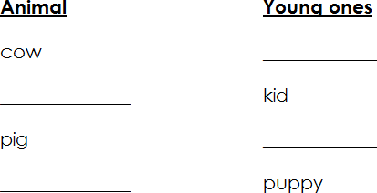

1. (a) Write **two** uses of water at home.

b) State any **two** items used to keep water at home.



53) Complete the table.

54a) Who heads a family?

1. State **two** roles of children at home.
2. Who breast feeds a baby at home?

55. What is wind?

1. State **one** use of wind to people.
2. Draw these conditions of weather.

|  |  |
| --- | --- |
| **windy** | **rainy** |
|  |  |

|  |
| --- |
| **PAPER 14** |
| **SECTION A**   1. Write any **one** characteristic of living things. 2. Mention any **one** common accident at home. 3. Why do people plant short grass in their compounds? 4. How does a cow protect itself from enemies? 5. Why is a dog important in a home? 6. State any **one** way of keeping the body clean   The diagram below shows two balloons. Use it to answer question 7     1. Which property of air is shown in the diagram? 2. Name any **one** common disease which affects people. 3. What is air? 4. State any **one** cause of changes in our environment. 5. How can you care for the part of the body drawn below? |

1. Name any **one** process involved in rain formation.
2. How is sunlight important to people?
3. Give any **one** way of keeping your classroom clean.
4. Name any **one** insect eaten by people.
5. Mention any **one** class of food.
6. State any **one** condition necessary for plant growth.
7. State the function of a watering can.
8. What is the best season for growing crops?
9. Give any **one** way of caring for animals.
10. How is the item below important to people?
11. Mention any **one** disease spread by mosquitoes.

____________________

1. Give any **one** member of a nuclear family.
2. Give any **one** way of making water safe for drinking at home.
3. Which part of the body is affected by trachoma?
4. Name any **one** product made from animal skins.
5. Apart from nimbus clouds, give any other type of clouds.
6. Name the type of soil best for pottery.
7. Write **one** food stuff which needs pounding in a mortar before cooking.
8. Which animal protects itself by changing colours?
9. What do birds use for breathing?
10. Draw this basic need.
11. Write any **one** source of food.

Medicine

1. Why do animals move from one place to another?
2. Name any **one** item used for cleaning our classroom.
3. State any **one** item found in a first aid box.
4. How do you care for your hair?
5. Name any **one** garden tool you know.
6. Mention any **one** role of a father in a family.
7. Name the wild animal drawn in the diagram below.

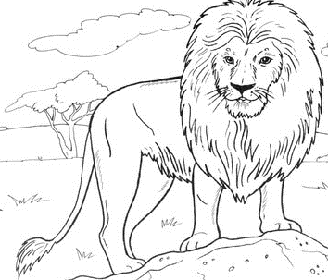

SECTION B

1. a) What is food?
   1. How is food useful in our bodies?
   2. Which food value do we get from eating the following?

|  |  |
| --- | --- |
|  |  |
|  |  |

1. a) Name any **one** gas found in the atmosphere.

(b) Write the gas in the atmosphere used for:

1. Breathing
2. Preserving drinks

c) What do we call the moving air?

1. a) Name the animal product used for making the item below.

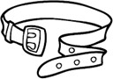

1. How do you care for animals?
2. Mention any **two** materials made from banana fibre.
3. a) Give any **two** uses of trees to people. (i)

(ii)

1. Name **one** animal which lives in trees.
2. Name any **one** tree that gives us fruits.
3. a) Write any **two** main body parts on an insect.
4. Which part of an insect is used for breathing?
5. State any **one** use of insects to people.
6. a) Name the animal drawn in the picture below.

|  |  |  |
| --- | --- | --- |
|  |  |  |
|  |
| 1. Where does the animal in the picture live? 2. How does the animal in the picture move? 3. a) Mention **two** sources of water.   b) Give **two** uses of water at home.     3. Match the sense organs to their uses. Eyes Smelling   Ears Seeing  Nose Feeling  Skin Hearing  Correct functions  Eyes Ears Nose Skin   1. a) Mention **two** materials used to clean yourself in a pit latrine   b) Give **two** ways you can keep the latrine clean. | | |

|  |  |
| --- | --- |
|  |  |
|  |  |
|  |  |
|  |  |



1. a) Name any **two** places where wild animals live.
2. How are wild animals useful to people?
3. Write **one** danger of wild animals to people.
4. Write the correct type of weather for each of the pictures in the diagram

|  |  |
| --- | --- |
|  |  |
|  |  |
|  |  |
|  |  |

1. a) What are non living things?
2. Give any **two** examples of non living things in your classroom.

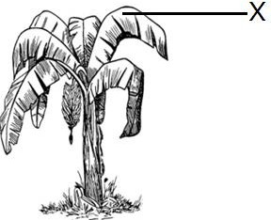



3. Give any **one** characteristic of living things.
4. a) Mention any **two** dangerous things that cause accidents.

b) Name the type of accident caused by each of the following.

1. Knife
2. Fire
3. Write the young one of the following animals
4. Cow :
5. Pig :
6. Sheep :
7. Hen :
8. The diagram below shows a common plant.
9. Name the plant shown above.
10. How is part X useful to the plant?
11. Give any **one** way of caring for the above plant.
12. Name the garden tool used to harvest the above plant.